VIRTUAL MACHINE INSTALL

Introduction
This document explains the installation of the virtual machine. This virtual machine is dedicated to the installation of OpenRailwayMap.

What we are going to Install
We are installing the following software:
- Kubuntu 20.04.1 desktop On a development computer we prefer install the open source browser Chromium.
- Chromium (default browser)
- Git
- Building Essentials
- Apache 2.4.1
- Postgres SQL 12
- PostGis
- Pgadmin 4
- PHP
- PHPPostgres
- nvm
- node
- OpenRailwayMap

Installation

Installing Kubuntu 20.04.1

Installation on physical pc
Download the kubuntu version from http://releases.ubuntu.com/20.04/.
Burn the ISO image to any drive you prefer and follow the instruction

Installation on VMWARE hypervis
Configure the virtual machine.
Download the kubuntu version from http://releases.ubuntu.com/20.04/.
Configure the CD/DVD to use the ISO image downloaded.
At the end of your installation some time you need to install the vmware tools. Run the following command
sudo apt-get update -ysudo systemctl is-enabled apache2.service
sudo apt-get upgrade -y
sudo apt-get install open-vm-tools open-vm-tools-desktop
To avoid having to type the password every time you type the command sudo run the command:
sudo visudo
After the line
# See sudoers(5) for more information on "#include" directives:
add the line
<your_username> ALL=(ALL) NOPASSWD: ALL

Installing curl
Most of time is useful to install curl (command line url). To install curl simply run:
sudo apt install curl

Installing UFW
A correctly functioning firewall is the most crucial part of the complete Linux system security. By default, Debian and Ubuntu distribution comes with a firewall configuration tool called UFW (Uncomplicated Firewall), is a most popular and easy-to-use command line tool for configuring and managing a firewall on Ubuntu and Debian distributions. To test if UFW is already installed run:
ufw –version
that returns

if UFW is not installed you can run
sudo apt install ufw
Once the installation is completed you can check the status of UFW by typing.
sudo ufw status verbose
On first install status will be inactive. You can activate or enable UFW firewall using the following command, which should load the firewall and enables it to start on boot.
sudo ufw enable
To disable UFW firewall, use the following command, which unloads the firewall and disables it from starting on boot.
sudo ufw disable
By default, the UFW firewall denies every incoming connections and only allow all outbound connections to server. This means, no one can access your server, unless you specifically open the port, while all the running services or applications on your server can be able to access the outside network.
The default UFW firewall polices are placed in the /etc/default/ufw file and can be altered using the following command:
sudo ufw default deny incoming
sudo ufw default allow outgoing
When installing a software package using APT package manager, it will include an application profile in /etc/ufw/applications.d directory that defines the service and hold UFW settings.
You can list all available application profiles on your server using the following command:
sudo ufw app list
Depending upon software package installations on your system the output will look similar to the following:
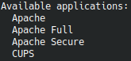

If you want to get more information about a particular profile and defined rules you can use the following command:
sudo ufw app info 'Apache Full'
that returns:
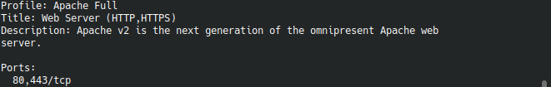

Installing Chromium
On a development computer we prefer install the open source browser Chromium.
To install Chromium simply run
sudo snap install chromium
To set chromium as the default browser open Computer→System Settings→Applications→Web Browser and set Chromium as the default browser.

Installing and Configuring Git

Installing Git
The option of installing with default packages is best if you want to get up and running quickly with Git, if you prefer a widely-used stable version, or if you are not looking for the newest available functionalities. If you are looking for the most recent release, you should jump to the section on installing from source.
Git is likely already installed in your Ubuntu 20.04 server. You can confirm this is the case on your server with the following command:
git --version
If you received output similar to the following
git version 2.25.1
then Git is already installed. If this is the case for you you can go the Git Configuration Section. Otherwise you can install it with the default package manager APT.
As always, use the apt package management tool to update your local package index with the command:
sudo apt update
With the update complete you can now install git with the command:
sudo apt install git
You can confirm Git is correctly installed by running the following command and checking that you receive relevant output:
git –version

Configuring Git
You should now configure Git so that the generated commit messages you make will contain your correct information your correct information and support you as you build your software project.
Configuration can be achieved by using the git config command. Specifically, we need to provide at least our name and email address because Git embeds this information into each commit we do. We can go ahead and add this information by typing:
git config --global user.name "Your Name"
git config --global user.email "youremail@domain.com"
We can display all of the configuration items that have been set by typing:
git config –list
The information you enter is stored in your Git configuration file, which you can optionally edit by hand with a text editor of your choice like this (we’ll use nano):
nano ~/.gitconfig
that results in Figure 1.
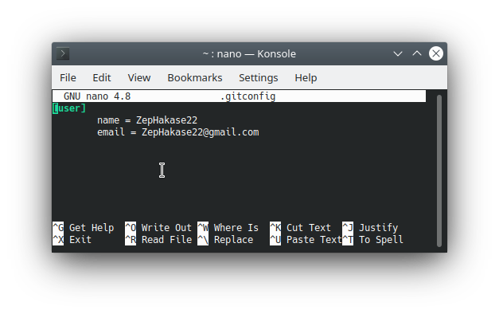Figure 1-The .gitconfig file.

Customizing Git Prompt
Adding current git branch name in Bash prompt with highlighted color can help to avoid a lot of problems with working on wrong git branches, which is a quite popular scenario to most of the developers sometime. This guide show to do it and explain some underneath concept of the hack.

The PS1 variable
PS1 stands for Prompt String 1. It is the first prompt available on Linux/UNIX shell. When you open your terminal, it will display the content defined in PS1 variable in your bash prompt. To change this prompt, just set new value to PS1 string.
The PS1 variable accept some control command: available control commands for PS1 are:
d - the date in "Weekday Month Date" format (e.g., "Tue May 26")
e - an ASCII escape character (033)
h - the hostname up to the first .
H - the full hostname
j - the number of jobs currently run in background
l - the basename of the shells terminal device name
n - newline
r - carriage return
s - the name of the shell, the basename of $0 (the portion following the final slash)
t - the current time in 24-hour HH:MM:SS format
T - the current time in 12-hour HH:MM:SS format
@ - the current time in 12-hour am/pm format
A - the current time in 24-hour HH:MM format
u - the username of the current user
v - the version of bash (e.g., 4.00)
V - the release of bash, version + patch level (e.g., 4.00.0)
w - Complete path of current working directory
W - the basename of the current working directory
! - the history number of this command
# - the command number of this command
$ - if the effective UID is 0, a #, otherwise a $
nnn - the character corresponding to the octal number nnn
a - an ASCII bell character (07)
\ \- a backslash
[ - begin a sequence of non-printing characters, which could be used to embed a terminal control sequence into the prompt
] - end a sequence of non-printing characters
So, for example the typical Bash prompt when the terminal supports the color prompt is:
PS1=\[\e]0;\u@\h: \w\a\]${debian_chroot:+($debian_chroot)}\[\e[01;32m\]\u@\h\[\e[00m\]:\[\e[01;34m\]\w\[\e[00m\]\$
where debian_chroot is deduced inside the .bashrc file.
The first part of PS1 string, until the \a control command is reserved fot xterm title. The second part is the prompt.
In Bash, the <Esc> character can be obtained with the following syntaxes:
\e
\033
\x1B
The “\e[0m” sequence removes all attributes (formatting and colors). It can be a good idea to add it at the end of each colored text. Here are the most commonly supported control sequences for formatting text. Their support depends on the used terminal
Set
Code | Description | Example | Preview
1 | Bold/Bright | echo -e "Normal \e[1mBold"
2 | Dim | echo -e "Normal \e[2mDim"
4 | Underlined | echo -e "Normal \e[4mUnderlined"
5 | Blink 1) | echo -e "Normal \e[5mBlink"
7 | Reverse (invert the foreground and background colors) | echo -e "Normal \e[7minverted"
8 | Hidden (useful for passwords) | echo -e "Normal \e[8mHidden"
Reset
Code | Description | Example | Preview
0 | Reset all attributes | echo -e "\e[0mNormal Text"
21 | Reset bold/bright | echo -e "Normal \e[1mBold \e[21mNormal"
22 | Reset dim | echo -e "Normal \e[2mDim \e[22mNormal"
24 | Reset underlined | echo -e "Normal \e[4mUnderlined \e[24mNormal"
25 | Reset blink | echo -e "Normal \e[5mBlink \e[25mNormal"
27 | Reset reverse | echo -e "Normal \e[7minverted \e[27mNormal"
28 | Reset hidden | echo -e "Normal \e[8mHidden \e[28mNormal"
For terminal with 8/16 colors these are the escape sequences
Foreground (text)
Code | Color | Example | Preview
39 | Default foreground color | echo -e "Default \e[39mDefault"
30 | Black | echo -e "Default \e[30mBlack"
31 | Red | echo -e "Default \e[31mRed"
32 | Green | echo -e "Default \e[32mGreen"
33 | Yellow | echo -e "Default \e[33mYellow"
34 | Blue | echo -e "Default \e[34mBlue"
35 | Magenta | echo -e "Default \e[35mMagenta"
36 | Cyan | echo -e "Default \e[36mCyan"
37 | Light gray | echo -e "Default \e[37mLight gray"
90 | Dark gray | echo -e "Default \e[90mDark gray"
91 | Light red | echo -e "Default \e[91mLight red"
92 | Light green | echo -e "Default \e[92mLight green"
93 | Light yellow | echo -e "Default \e[93mLight yellow"
94 | Light blue | echo -e "Default \e[94mLight blue"
95 | Light magenta | echo -e "Default \e[95mLight magenta"
96 | Light cyan | echo -e "Default \e[96mLight cyan"
97 | White | echo -e "Default \e[97mWhite"

Background
Code | Color | Example | Preview
49 | Default background color | echo -e "Default \e[49mDefault"
40 | Black | echo -e "Default \e[40mBlack"
41 | Red | echo -e "Default \e[41mRed"
42 | Green | echo -e "Default \e[42mGreen"
43 | Yellow | echo -e "Default \e[43mYellow"
44 | Blue | echo -e "Default \e[44mBlue"
45 | Magenta | echo -e "Default \e[45mMagenta"
46 | Cyan | echo -e "Default \e[46mCyan"
47 | Light gray | echo -e "Default \e[47mLight gray"
100 | Dark gray | echo -e "Default \e[100mDark gray"
101 | Light red | echo -e "Default \e[101mLight red"
102 | Light green | echo -e "Default \e[102mLight green"
103 | Light yellow | echo -e "Default \e[103mLight yellow"
104 | Light blue | echo -e "Default \e[104mLight blue"
105 | Light magenta | echo -e "Default \e[105mLight magenta"
106 | Light cyan | echo -e "Default \e[106mLight cyan"
107 | White | echo -e "Default \e[107mWhite"

Some terminals can support 88 or 256 colors. Here are the control sequences that permit you to use them.
For using one of the 256 colors on the foreground (text color), the control sequence is “<Esc>[38;5;ColorNumberm” where ColorNumber is one of the following colors:
Foreground (text)
Examples:
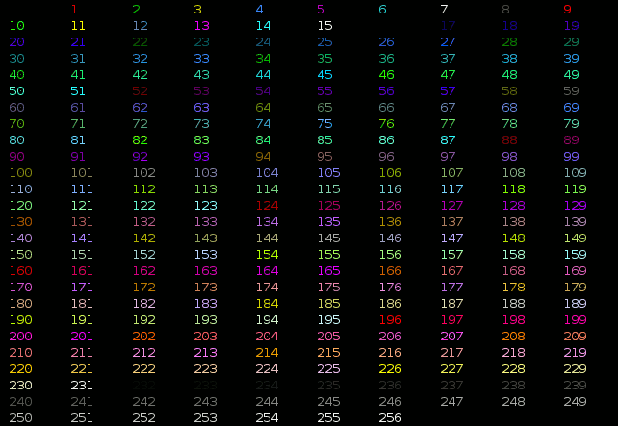Figure 3-Foreground text color in 256 colors
Code (Bash) | Preview
echo -e "\e[38;5;82mHello \e[38;5;198mWorld"
for i in {16..21} {21..16} ; do echo -en "\e[38;5;${i}m#\e[0m" ; done ; echo

For using one of the 256 colors on the background, the control sequence is “<Esc>[48;5;ColorNumberm” where ColorNumber is one of the following colors:
Background
Examples:
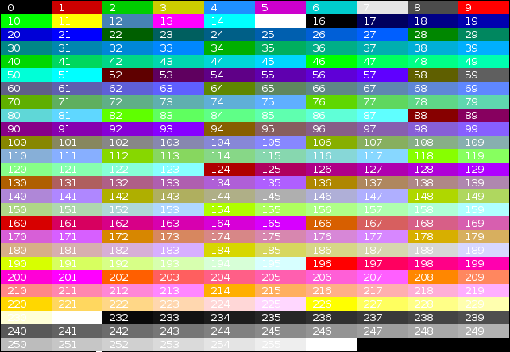Figure 4-Background in 256 colors
Code (Bash) | Preview
echo -e "\e[40;38;5;82m Hello \e[30;48;5;82m World \e[0m"
for i in {16..21} {21..16} ; do echo -en "\e[48;5;${i}m \e[0m" ; done ; echo
Terminals allow attribute combinations. The attributes must be separated by a semicolon (“;”).
Examples:
Description | Code (Bash) | Preview
Bold + Underlined | echo -e "\e[1;4mBold and Underlined"
Bold + Red forground + Green background | echo -e "\e[1;31;42m Yes it is awful \e[0m"
So our PS1 is:
(<debian_chroot>)<username>@<hostname>:~/<current_work_directory> $
If you want add the current branch first of all we need to get the current branch. We can provide this with the following function:
parse_git_branch() {
git branch 2> /dev/null | sed -e '/^[^*]/d' -e 's/* \(.*\)/(\1)/'
}
The parse_git_branch function will return the current git branch if we are currently in a git repo directory, otherwise it will return empty string. In this function, git branch command will be used. This command will list of local git branches with the * symbol before the current branch:
For example:
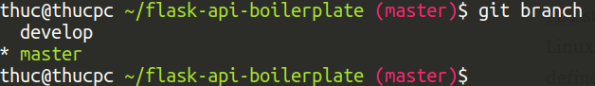
If we are not in a git repo directory, the command will output something like this to stderr:
We surely don’t want this to appear in our prompt, so we redirect the stderr to /dev/null with this: 2> /dev/null.
The last part is using sed command to extract the current branch name (the line starting with symbol *) from the git branch output.
git branch 2> /dev/null | sed -e '/^[^*]/d' -e 's/* \(.*\)/(\1)/'
Where -e '/^[^*]/d' will delete all lines that do not start with symbol *, and the -e 's/* \(.*\)/(\1)/' will replace (substitute) the current branch line (with symbol * and a space at the beginning) with the branch name, putting it in a pair of bracket () i.e.:
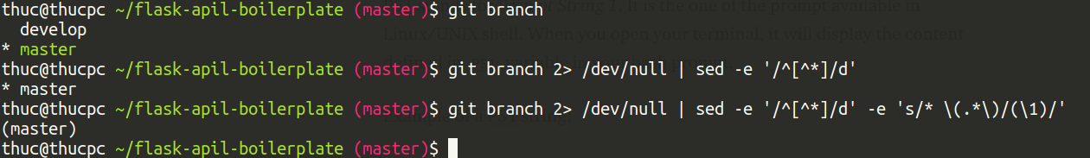
So if we add to our PS1 variable after the \w command “ \\[\e[91m\]$(parse_git_branch)\[\e[00m\]$ “ we should obtain as result:
zep@TripOnTrain:~/Programs/MyConfiguration(master) $

Installing Build Essentials
GCC, the GNU Compiler Collection is a compiler system developed to support various programming languages. It is a standard compiler used in most projects related to GNU and Linux, for example, Linux kernel. The objective of this tutorial is to install GCC the C compiler on Ubuntu 20.04 LTS Focal Fossa Linux. This will be achieved by using the apt install command.
Although you can install the C compiler separately by installation of the gcc package, the recommended way to install the C compiler on Ubuntu 20.04 is by installation of the entire development package build-essential. Use the following commands
sudo apt update && sudo apt upgrade && sudo apt dist-upgrade
sudo apt install build-essential
Check C compiler version with the command:
gcc –version
that will result in:
